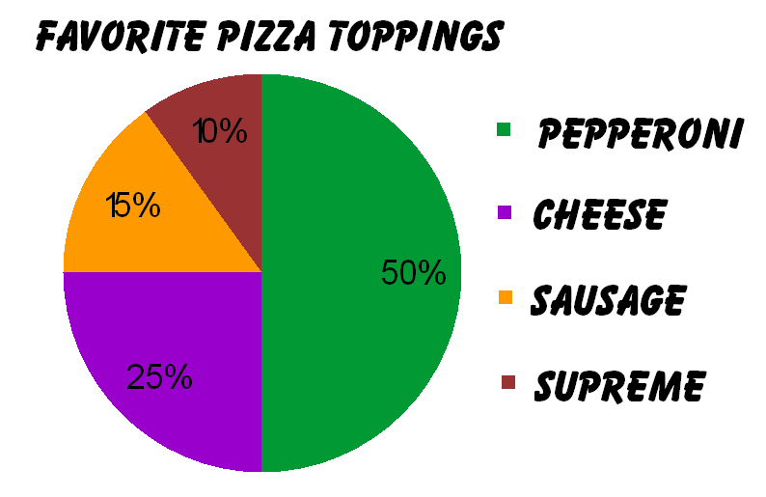

1. 1 – 5 Multiple Choice
2. **What are the most favorite pizza toppings?**
3. **Supreme**
4. **Cheese**
5. **Pepperoni**
6. **Sausage**
7. **What are the least favorite pizza toppings?**
8. **Pepperoni**
9. **Cheese**
10. **Sausage**
11. **Supreme**
12. **What is the second most favorite pizza toppings?**
13. **Cheese**
14. **Sausage**
15. **Supreme**
16. **Pepperoni**
17. **What is the second least favorite pizza toppings?**
18. **Pepperoni**
19. **Sausage**
20. **Supreme**
21. **Cheese**
22. **What is the percentage of the cheese?**
23. **10%**
24. **25%**
25. **50%**
26. **30%**

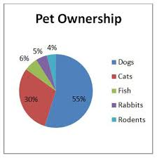

1. **6 – 10 Multiple choice**
2. **What is the least pet ownership?**
3. **Dogs**
4. **Cats**
5. **Fish**
6. **Rodents**
7. **What is the most pet ownership?**
8. **Dogs**
9. **Cats**
10. **Rabbits**
11. **Fish**
12. **What is the percentage of the dogs?**
13. **77%**
14. **55%**
15. **50**
16. **30**
17. **What is the second most pet ownership?**
18. **Dogs**
19. **Cats**
20. **Fish**
21. **Rabbits**
22. **What is the second least pet ownership?**
23. **Dogs**
24. **Cats**
25. **Rabbit**
26. **Rodents**

